**Experiment no. 4**

**Step 1: Select the Operating System Windows followed by either 32bit or 64 bit based on your OS type.**

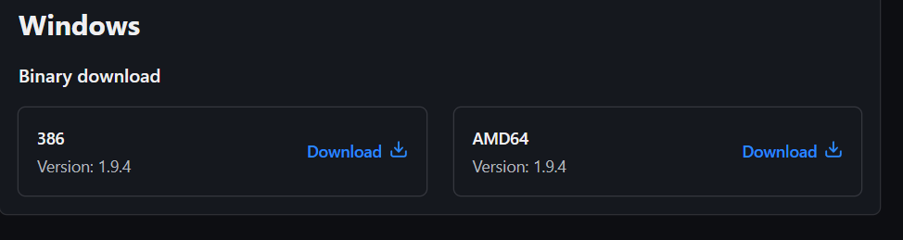

**Step 2:-Extract the downloaded setup file Terraform.exe in C:\Terraform directory**

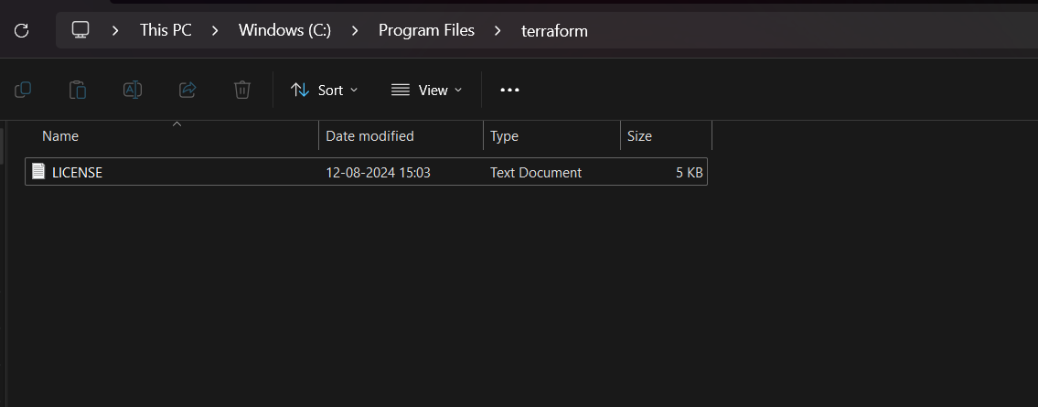

**Step 3 Set the System path for Terraform in Environment Variables**

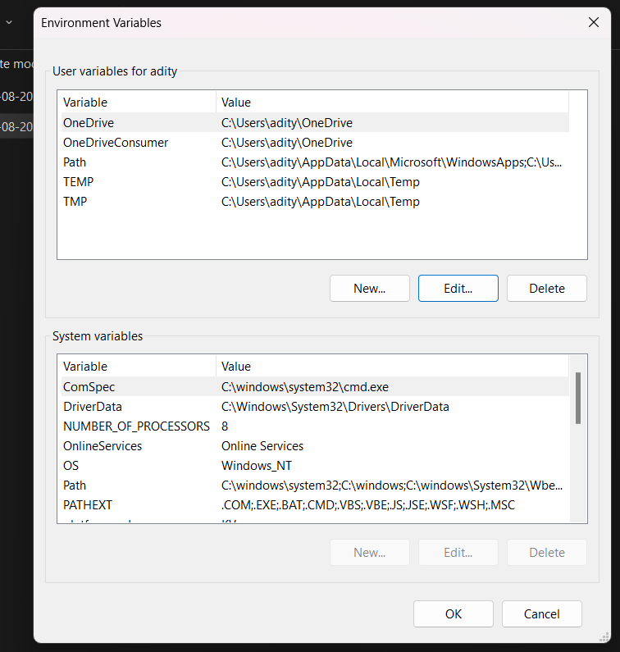

**Step 4 open the powershell**

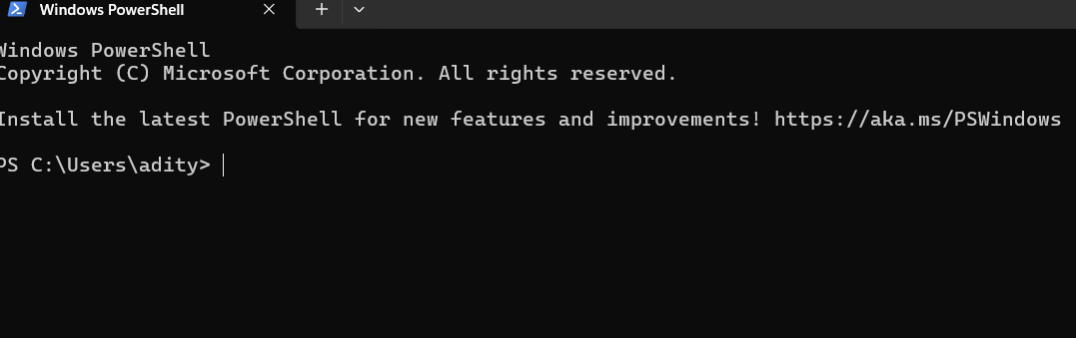

**Step 5:Open Terraform in PowerShell and check its functionality**

